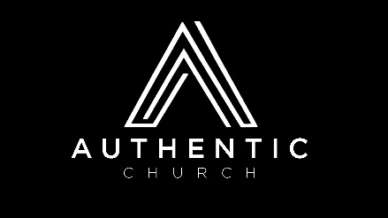
Series: RISE UP – “Thriving In An Uncertain World”
QUARTER 2 of 2021 – Studying the book of DANIEL

DATE | WEEK’S PASSAGE TO STUDY | DEVELOPING STRONG SPIRITUAL DISCIPLINES | POTLUCK THEME
Apr 11 | Daniel 1 | Learning about the spiritual discipline of FASTING | Healthy Eating Night
Apr 18 | Daniel 2 | Learning how to study the BIBLE | Mexican
Apr 25 | Daniel 3 | The need for relationships with other believers in FELLOWSHIP | Baked Potato Bar
May 2 | Daniel 4 | Are you right with God? Learning about REPENTANCE | Soup & Salad
May 9  MOTHER’S DAY | Daniel 5 | What is PRAYER and how do we pray effective prayers? | Pasta Dishes, Salads, Bread, Dessert
May 16 | Daniel 6 | Are we ready for what is to come through PERSECUTION? | Healthy Eating Night
May 23 | Daniel 7 | How does God speak to us? Does He still talk through dreams & visions? What is the PROPHETIC? | Sub Sandwiches, Salads, Fruit, Dessert
May 30 | Daniel 8 | Let’s talk about characteristics of a DISCIPLE of Christ | Mexican
Jun 6 | Daniel 9 | Do you know what the Bible says about what is to come? What is ESCHATOLOGY? | Pasta, Salad, Bread, Dessert
Jun 13 | Daniel 10 | Living through hardships and learning to PERSEVERE | Soup & Salad
Jun 20  FATHER’S DAY | Daniel 11 | Are you aware of the SIGNS OF THE TIMES? | BBQ Dinner
Jun 27 | Daniel 12 | If we know the time is short, are we sharing our faith with others? What is EVANGELISM? | Sub Sandwiches, Salads, Fruit, Dessert

